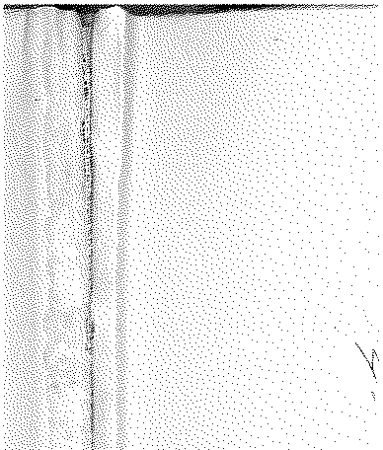

# Annual Vol ume of

TH E LAW S



# of Western N igeria

1962

## containin g

the Laws of Western Nigeria

and subsidiary legisla tion made thereunder



LOS ANGELES COUNTY

LAW LIBRARY

***B 372***

W.R.L.N.

**W.N.L.N. 177 .of 1962**

*The Local Government Law (Cap. 68)*

THE CONTROL OF DRUMMING ADOPTIVE BYE-LAWS IBEJU DISTRICT COUNCIL

DATE OF COMMENCEMENT: 14TH JUNE, 1962

**Notice is hereby given that in exercise of the powers conferred upon the** Ibeju District Council by sections 83 (2) and 276 of the Local Government Law, Cap. 68., the Ibeju District Council in accordance with section 83 (3) *(a)* **of the Local Government Law has resolved at its meeting held on the 19th** day of May, 1962, that the Control of Drumming Adoptive (Amendment)

297 of 1957. Bye-laws, 1957 be adopted and that the First Schedule to the Ibeju District

**Amendment to W.R.L.N.** 201 of 1958.

Council Control of Drumming Adoptive Bye-laws published as W.R.L.N. 201 of 1958 be amended by the inclusion of the following descriptions of **drums thereto:-**

Waka Agidigbo

J. M. BECKLEY,

***Permanent Secretary,***

*Ministry of Local Government*



Ibadan, 4th June, 1962.